##### Small Lady D-Joy Bag

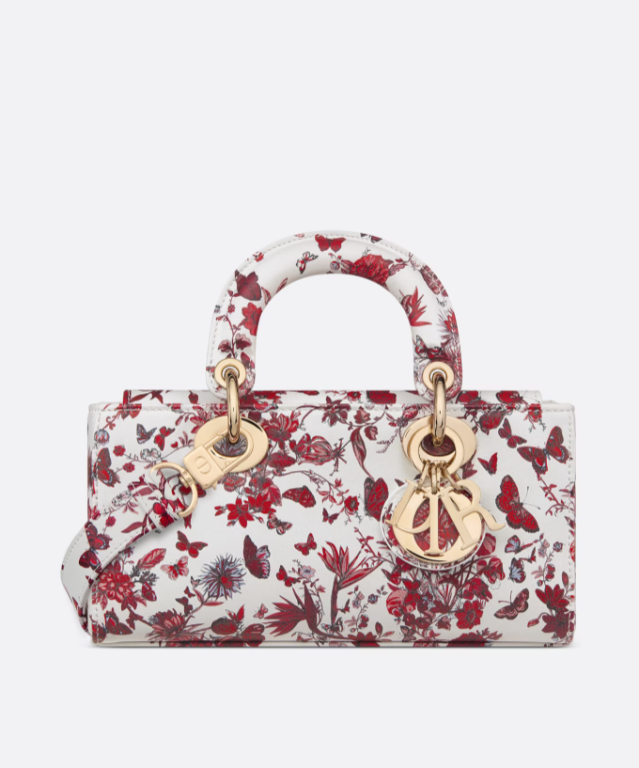  
The Small Lady D-Joy Bag is a stylish and elegant accessory from the luxury fashion brand Dior. It's part of the Lady Dior collection, which is known for its timeless design and iconic quilting pattern.

The Small Lady D-Joy Bag features a compact silhouette with soft curves and the signature Cannage quilting, which adds texture and sophistication to the design. It often includes the iconic "D.I.O.R." charms hanging from the handles, further enhancing its luxurious appeal. This bag is designed to be carried by hand or worn on the crook of the arm, making it perfect for both formal occasions and everyday use.

If you're interested in purchasing a Small Lady D-Joy Bag, you can explore Dior's official website or visit their boutique stores to see the latest offerings. Dior offers this bag in various colors, materials, and finishes, allowing you to choose the option that best suits your style preferences. Additionally, you can also check with reputable luxury retailers or online platforms specializing in designer handbags to see if they have the Small Lady D-Joy Bag available for purchase.